Student Name: __________________
Class and Section __________________
Total Points (20 pts) __________________
Due: Feb 28, 2011 before the class

Project: Accessing and updating a Staff table (Visual JSF)

CSCI 5520 Rapid Java Application Development
Armstrong Atlantic State University

Problem Description:

Write a Visual JSF program that views, inserts, and updates staff information stored in a database, as shown in the following figure. The view button displays a record with a specified ID. The Staff table is created as follows:
create table Staff (
id char(9) not null,
lastName varchar(15),
firstName varchar(15),
mi char(1),
address varchar(20),
city varchar(20),
state char(2),
telephone char(10),
email varchar(40),
primary key (id)
);

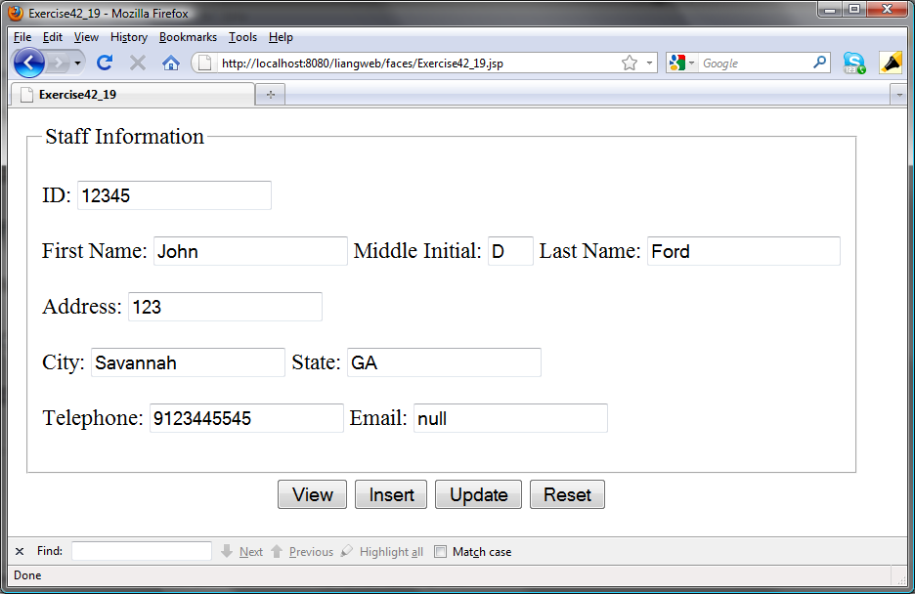

Source code: (Name your program Exercise33_09)

Screen shot:

What to submit?

- This document.
- Save/Compile and Submit to LiveLab (Make sure your program compiles! You must submit the program regardless whether it complete or incomplete, correct or incorrect)

2. Fill in self-evaluation:

- Can you display the form? _________
- Can you connect to the database? ______
- Is the View button implemented correctly? _______________
- Is the Insert button implemented correctly? ________
- Is the Update button implemented correctly? ________
- Is the Clear button implemented correctly? ________

Solution:

<%@page contentType="text/html" pageEncoding="windows-1252"%>
<!DOCTYPE HTML PUBLIC "-//W3C//DTD HTML 4.01 Transitional//EN"
"http://www.w3.org/TR/html4/loose.dtd">

<jsp:useBean id = "backend"
class = "chapter42.Exercise42_19" scope = "session" >
</jsp:useBean>

<jsp:setProperty name = "backend" property = "*" />

<%! String message = "";%>

<%
if (request.getParameter("submit") != null) {
if (request.getParameter("submit").toString().equalsIgnoreCase("view")) {
backend.view(request);
} else if (request.getParameter("submit").toString().equalsIgnoreCase("insert")) {
message = backend.insert(request) + " rows affected.";
} else if (request.getParameter("submit").toString().equalsIgnoreCase("update")) {
message = backend.update(request) + " rows affected.";
} else if (request.getParameter("submit").toString().equalsIgnoreCase("reset")) {
backend.reset();
}
}
%>

<html>
<head>
<meta http-equiv="Content-Type" content="text/html; charset=UTF-8">
<title>Exercise42_19</title>
</head>
<body>
<table>
<tr>
<td>
<fieldset>
<legend>Staff Information</legend>
<form action='Exercise42_19.jsp' method='post'>
<p>
<label >ID: </label><input name="id" value = <jsp:getProperty name = "backend" property = "id" /> ><br /><br />
<label >First Name: </label><input name="firstname" value = <jsp:getProperty name = "backend" property = "firstname" /> >
<label for='mi'>Middle Initial: </label><input type='text' size = "1" name='mi' value = <jsp:getProperty name = "backend" property = "mi" /> >
<label for='lastname'>Last Name: </label><input type='text' name='lastname' value = <jsp:getProperty name = "backend" property = "lastname" /> ><br /><br />
<label for='address'>Address: </label><input type='text' name='address' value = <jsp:getProperty name = "backend" property = "address" /> ><br /><br />
<label for='city'>City: </label><input type='text' name='city' value = <jsp:getProperty name = "backend" property = "city" /> >
<label for='state'>State: </label><input type='text' name='state' value = <jsp:getProperty name = "backend" property = "state" /> ><br /><br />
<label for='telephone'>Telephone: </label><input type='text' name='telephone' value = <jsp:getProperty name = "backend" property = "telephone" /> >
<label for='email'>Email: </label><input type='text' name='email' value = <jsp:getProperty name = "backend" property = "email" /> ><br />

</fieldset>
</td>
</tr>
<tr align="center">
<td>
<button name='submit' value='view' type='submit'>View</button>
<button name='submit' value='insert' type='submit'>Insert</button>
<button name='submit' value='update' type='submit'>Update</button>
<button name='submit' value='reset' type='submit'>Reset</button>
</td>
</tr>
<tr align="center">
<td>
<%= message%>
</td>
</tr>
</form>
</tr>
</table>
</body>
</html>

/*
* To change this template, choose Tools | Templates
* and open the template in the editor.
*/
package chapter42;

import java.sql.*;
import javax.servlet.http.HttpServletRequest;

public class Exercise42_19 {

String id = "";

public String getId() {
return id;
}

public void setId(String id) {
this.id = id;
}
String firstname = "";

public String getFirstname() {
return firstname;
}

public void setFirstname(String firstname) {
this.firstname = firstname;
}
String mi = "";

public String getMi() {
return mi;
}

public void setMi(String mi) {
this.mi = mi;
}
String lastname = "";

public String getLastname() {
return lastname;
}

public void setLastname(String lastname) {
this.lastname = lastname;
}
String address = "";

public String getAddress() {
return address;
}

public void setAddress(String address) {
this.address = address;
}
String city = "";

public String getCity() {
return city;
}

public void setCity(String city) {
this.city = city;
}
String state = "";

public String getState() {
return state;
}

public void setState(String state) {
this.state = state;
}
String email = "";

public String getEmail() {
return email;
}

public void setEmail(String email) {
this.email = email;
}
String telephone = "";

public String getTelephone() {
return telephone;
}

public void setTelephone(String telephone) {
this.telephone = telephone;
}
Connection connection;
ResultSet result;

public ResultSet getResult() {
return result;
}

public Exercise42_19() {
try {
System.out.println("Contructor trying initialization...");
initialize();
} catch (Exception ex) {
ex.printStackTrace();
}
}

private void initialize() throws ClassNotFoundException {
try {
Class.forName("com.mysql.jdbc.Driver");
connection = DriverManager.getConnection("jdbc:mysql://localhost/javabook", "scott", "tiger");
System.out.println("Initialized!");
} catch (SQLException e) {
e.printStackTrace();
}
}

public void view(HttpServletRequest request) {
Statement s = null;
try {
s = connection.createStatement();
s.executeQuery("SELECT * FROM Staff WHERE id=" + id);
result = s.getResultSet();

if (result.next()) {
id = result.getString("id");
firstname = result.getString("firstname");
mi = result.getString("mi");
lastname = result.getString("lastname");
address = result.getString("address");
city = result.getString("city");
state = result.getString("state");
email = result.getString("email");
telephone = result.getString("telephone");
}
} catch (Exception e) {
} finally {
}
}

public int insert(HttpServletRequest request) {
PreparedStatement s = null;
int count = 0;
try {
s = connection.prepareStatement("INSERT INTO Staff " + "(id, lastName, firstName, mi, address, city, state, telephone, email) " + "VALUES (?,?,?,?,?,?,?,?,?)");
s.setString(1, id);
s.setString(2, lastname);
s.setString(3, firstname);
s.setString(4, mi);
s.setString(5, address);
s.setString(6, city);
s.setString(7, state);
s.setString(8, telephone);
s.setString(9, email);
count = s.executeUpdate();
s.close();
} catch (Exception ex) {
ex.printStackTrace();
} finally {
return count;
}
}

public int update(HttpServletRequest request) {
PreparedStatement s = null;
int count = 0;
try {
s = connection.prepareStatement("update Staff set lastName = ?, firstName = ?, mi = ?, address = ?, city = ?, state = ?, telephone = ?, email = ? WHERE id = ?");
s.setString(9, id);
s.setString(1, lastname);
s.setString(2, firstname);
s.setString(3, mi);
s.setString(4, address);
s.setString(5, city);
s.setString(6, state);
s.setString(7, telephone);
s.setString(8, email);
count = s.executeUpdate();
s.close();
} catch (Exception ex) {
ex.printStackTrace();
} finally {
return count;
}

}

public void reset() {
id = "";
firstname = "";
mi = "";
lastname = "";
address = "";
city = "";
state = "";
email = "";
telephone = "";

}
}

